SET A

1. Create a stack implemented using a list to store the names of Employees of a Company. Write the python code to show the push operation in this stack.
2. Write the SQL queries for (i) to (iii) and find the outputs for SQL queries for the (iv) and (v) which are based on the given tables.

Table: CABIN LUGGAGES

| LUGGAGECODE | NAME | PRICE | BRAND | QTY_STORE |
| --- | --- | --- | --- | --- |
| L001 | ESTRO | 10000 | VIP | 100 |
| L002 | SPACIO | 15000 | TOMMY | 150 |
| L003 | DESIRE | 20000 | AMERICAN TOURISTER | 200 |
| L004 | HIGH RISE | 7000 | SKYBAGS | 250 |
| L005 | EASY TRAVEL | 25000 | SKYBAGS | 100 |

Table: SALE

| LUGGAGECODE | QTY_SOLD | QUARTER |
| --- | --- | --- |
| L001 | 10 | 1 |
| L003 | 5 | 1 |
| L002 | 20 | 2 |
| L003 | 10 | 2 |
| L001 | 15 | 3 |
| L002 | 20 | 3 |
| L005 | 10 | 3 |
| L003 | 15 | 4 |

1. To display all the details of those luggages whose brand name starts with S.

ans - SELECT * FROM `CABIN LUGGAGES` WHERE BRAND LIKE 'S%';

1. To display the name and price of those luggages which have prices in the range between 5000 and 15000.

ANS - SELECT NAME,PRICE FROM `CABIN LUGGAGES` WHERE PRICE BETWEEN 5000 AND 15000;

1. To display total quantity in store of TOMMY and VIP brand.

ANS - SELECT BRAND , QTY_STORE FROM `CABIN LUGGAGES` WHERE BRAND IN ('TOMMY','VIP');

1. Select quarter, sum(qty_sold) from sale group by quarter;

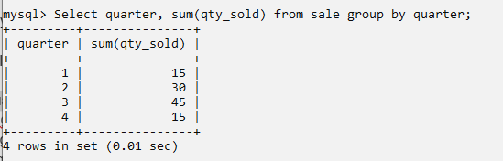

1. Select Luggagecode, name, qty_store, sum(qty_sold), from Luggages, Sale where Luggages.Luggagecode=sales.Luggagecode group by sale.Luggagecode;

ANS Select c.Luggagecode, name, qty_store, sum(qty_sold) from `CABIN LUGGAGES` c, Sale where c.Luggagecode=sale.Luggagecode group by sale.Luggagecode;

